1. Tiles
Two parts of this square design are shaded black.
Two parts are shaded grey.
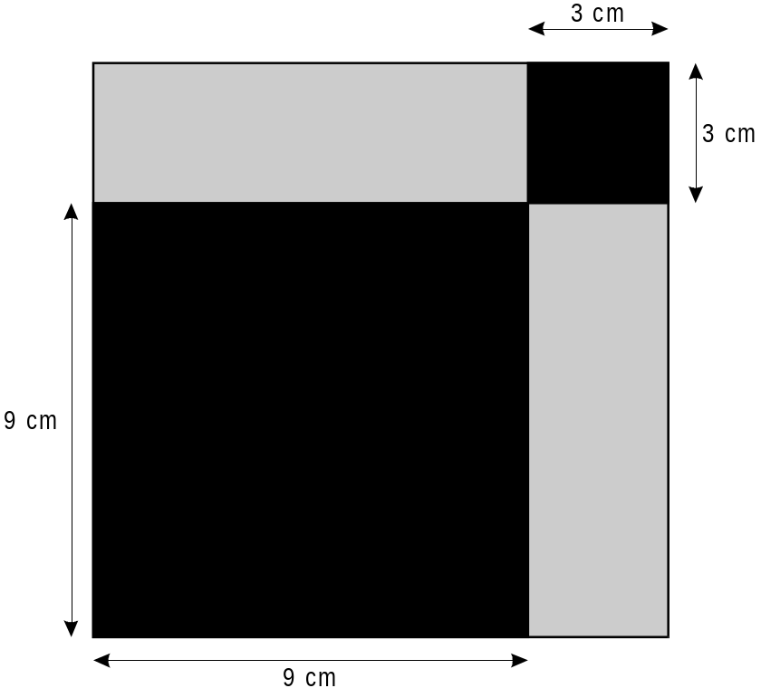

Show that the ratio of black to grey is 5 : 3


2 marks

